**DAY-3**

**8.Develop a system using UML for Recruitment System, to recruit the applicant for a particular job in the company. It was controlled by the central management system to manage the details of the particular applicant who has to be recruited by a company.**

**AIM:-**

To develop a system using UML for RECRUITMENT SYSTEM.

UML DESIGNS:-

1.USE CASE DIAGRAM:

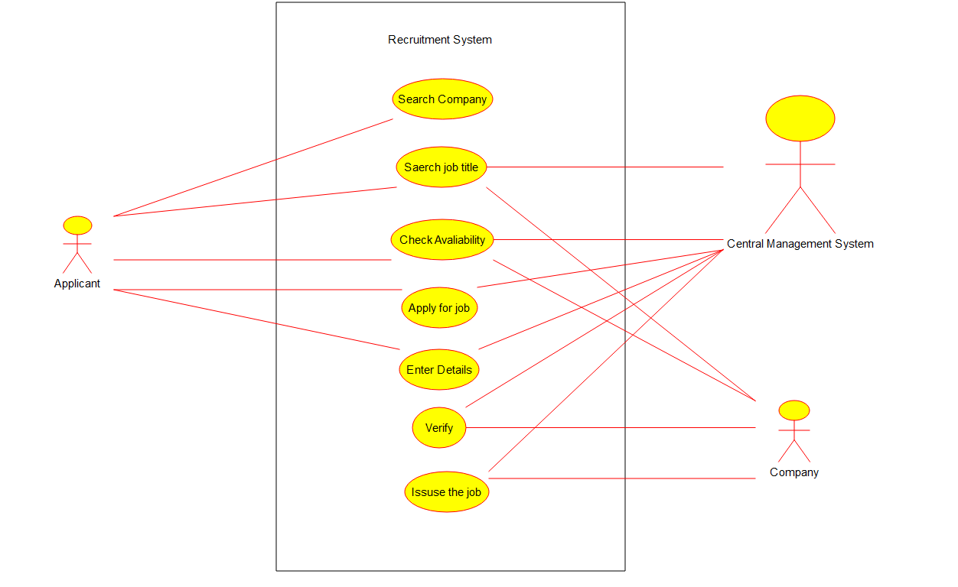

2.CLASS DIAGRAM:

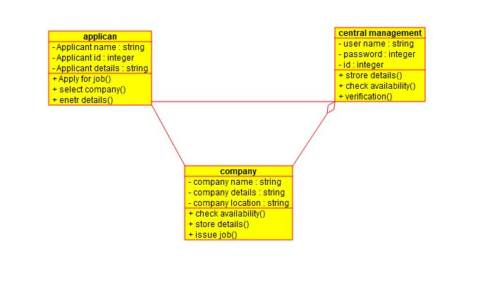

3.SEQUENCE DIAGRAM:

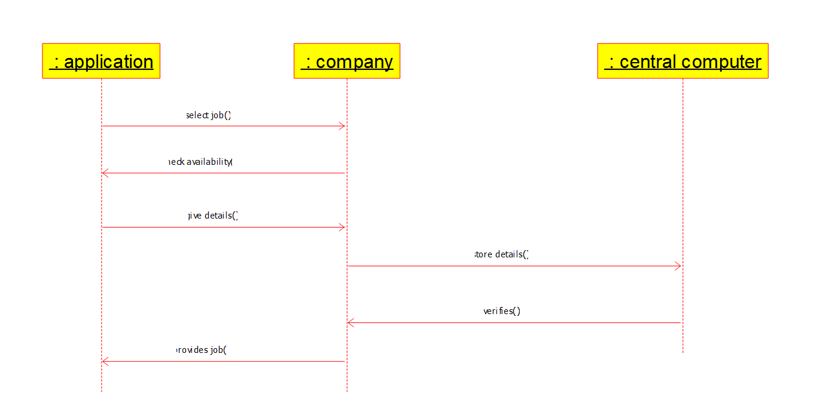

4.ACTIVITY DIAGRAM:

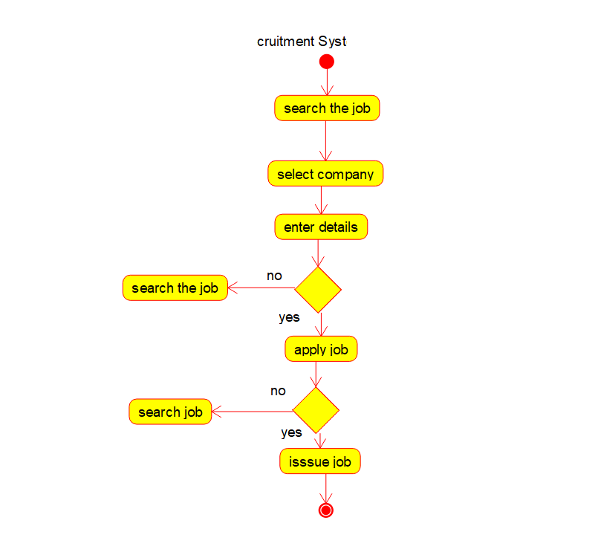

5.COLLABRATION DIAGRAM:

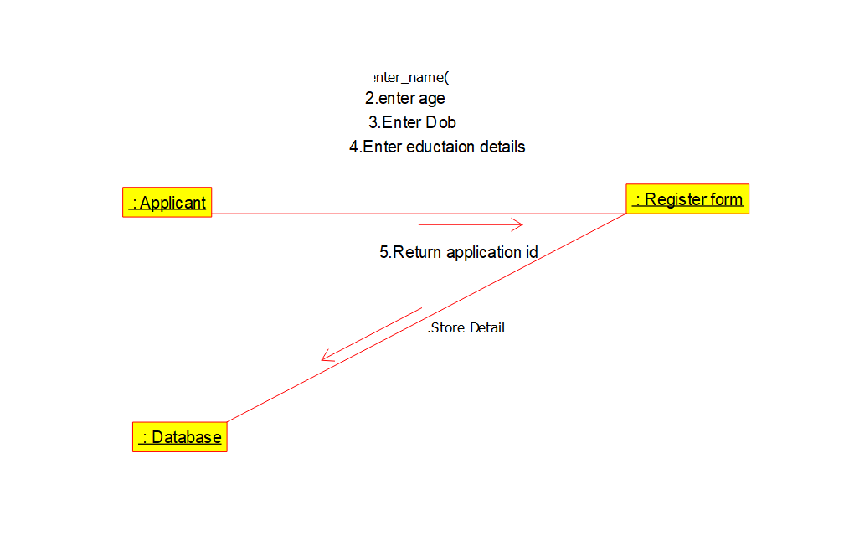

6.DEPLOYMENT DIAGRAM:

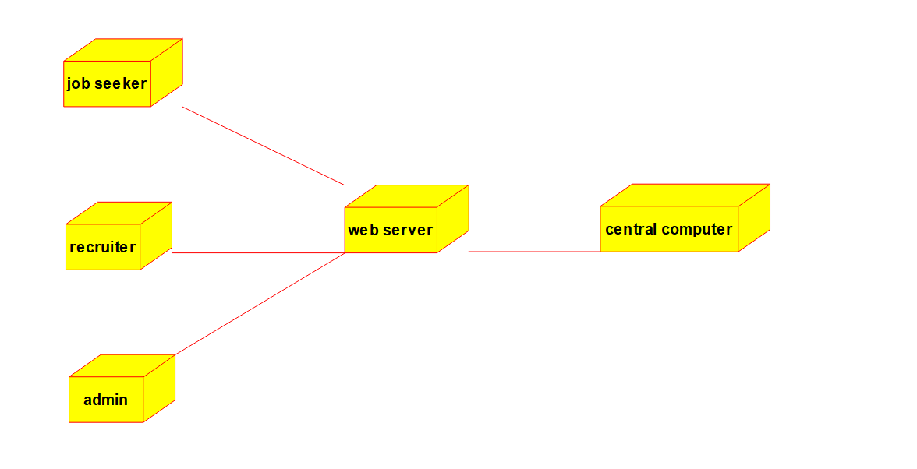

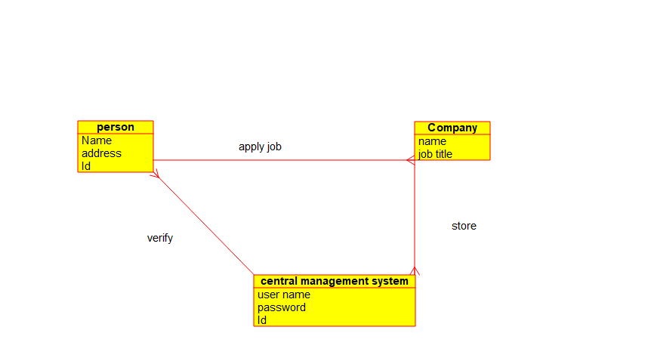 7.STATE DIAGRAM:

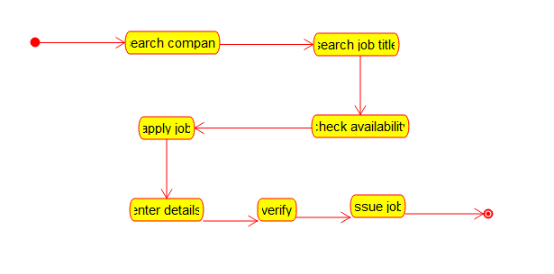

**9. Develop a system using UML for Blood Bank Registration System. The system should have the list of donors and the hospitals can check for the donor's availability and get their appointment. The donor and the hospital can interact with the central system.**

**AIM:-** To develop a system using UML diagrams for Blood Bank Registration System.

UML DESIGNS:-

1.USE CASE DIAGRAM:

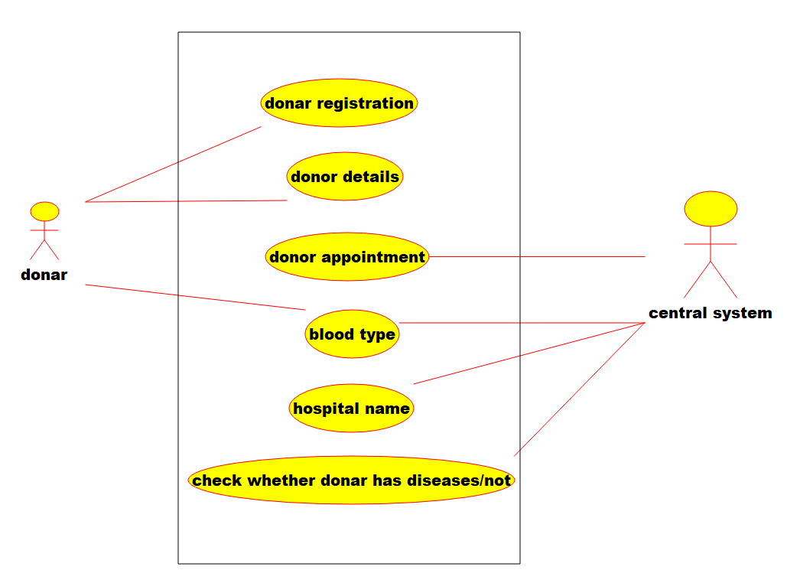

2.CLASS DIAGRAM:

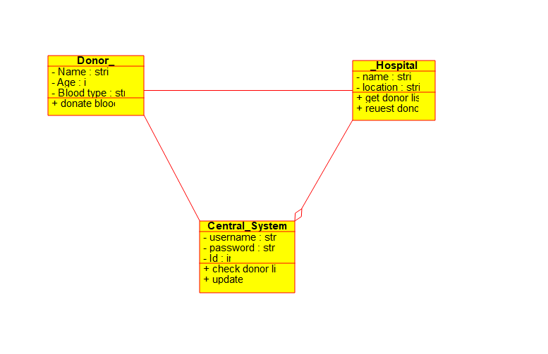

3.ACTIVITY DIAGRAM:

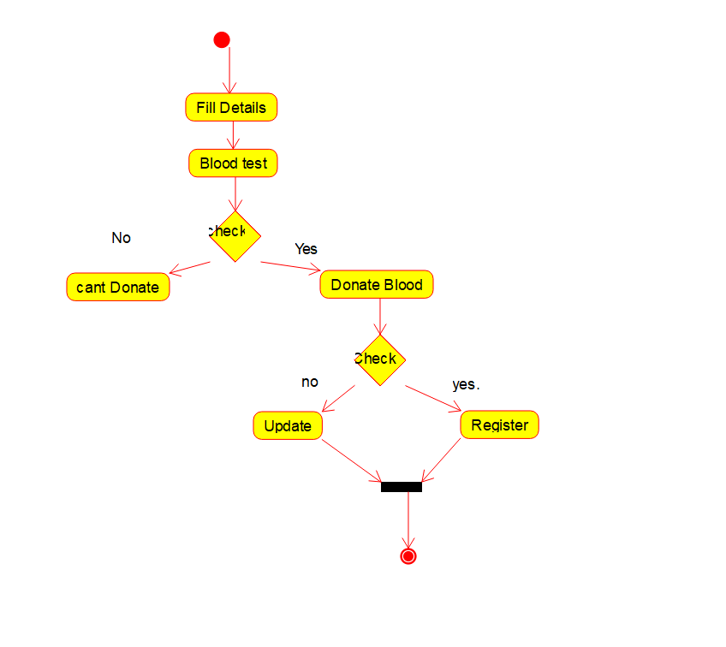

4.COLLABORATION DIAGRAM:

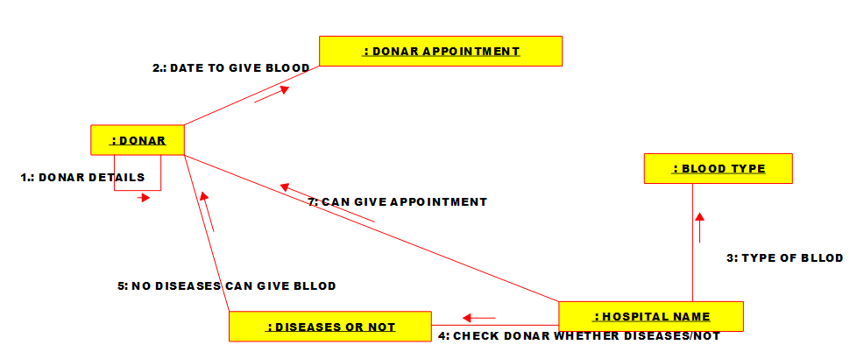

5.STATE DIAGRAM:

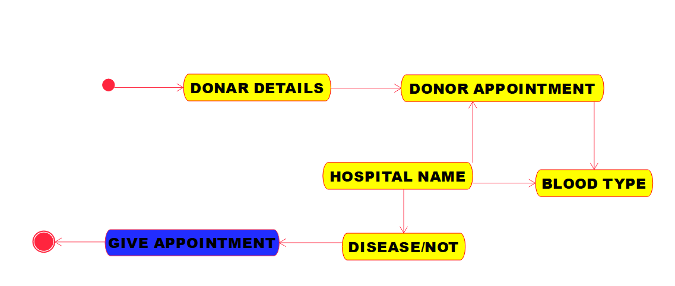

6.SEQUENCE DIAGRAM:

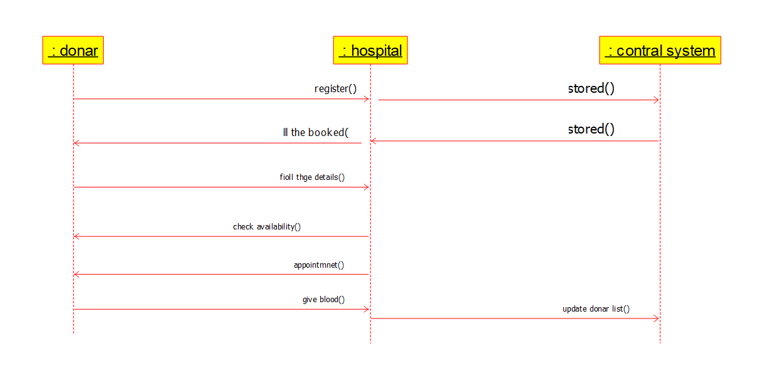

7.COLLABRATION DIAGRAM:

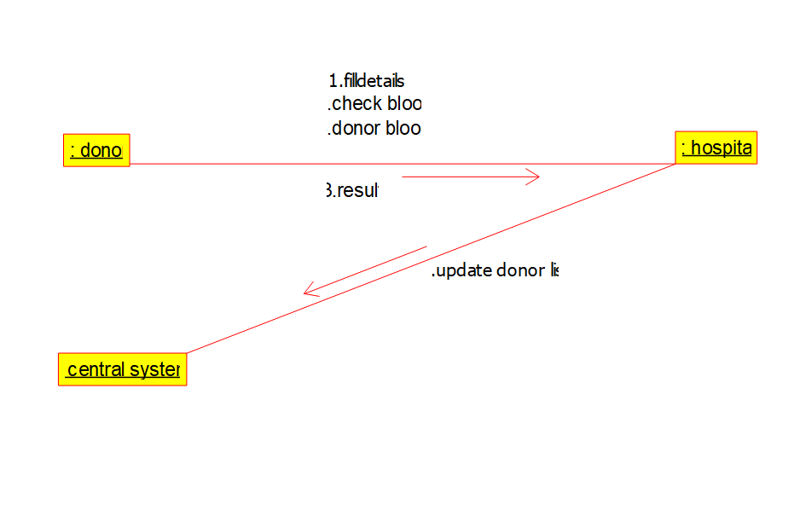

8.DEPLOYMENT DIAGRAM:

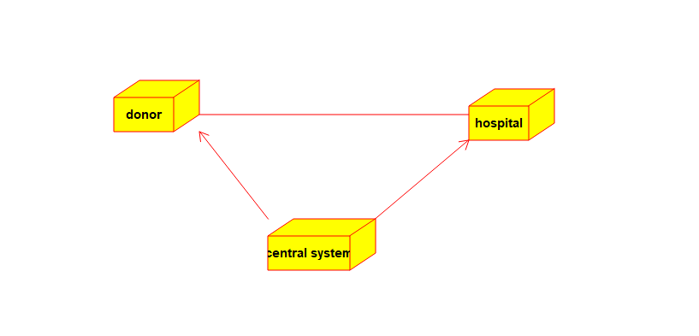

**10.** **Develop a system using UML for Food Order System. In this system, the customer can place orders and purchase items with the aid of the dealer and central food system. These orders are verified and the items are delivered to the customer.**

**AIM:-**

To develop a system using UML for FOOD ORDERING System.

UML DESIGNS:-

1.USE CASE:

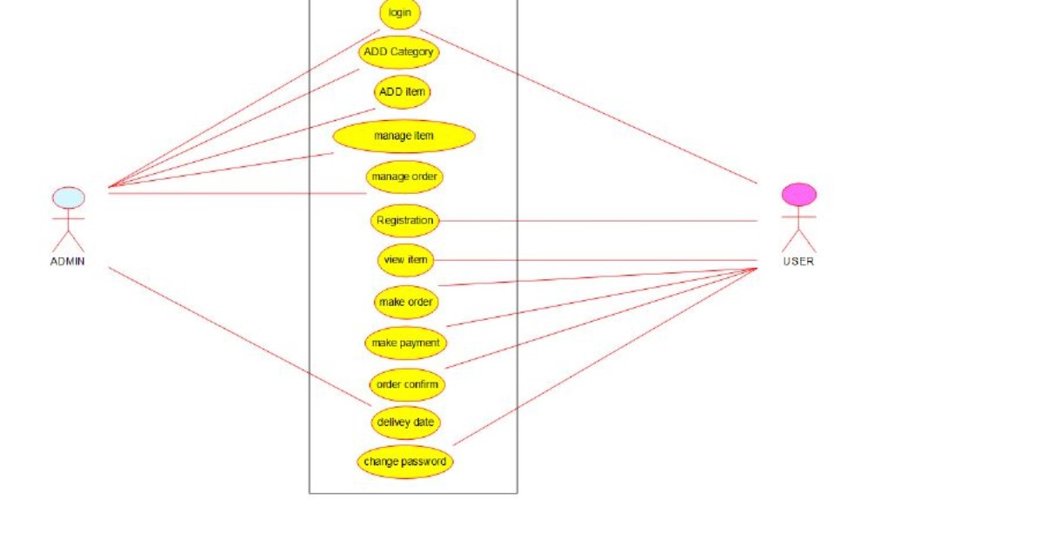

2.CLASS DIAGRAM:

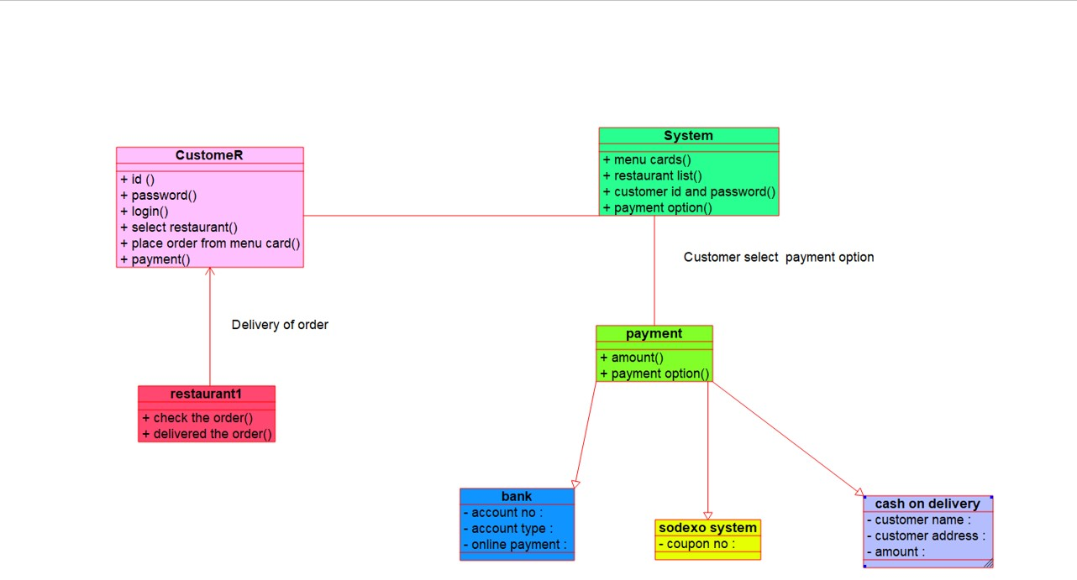

3.ACTIVITY DIAGRAM:

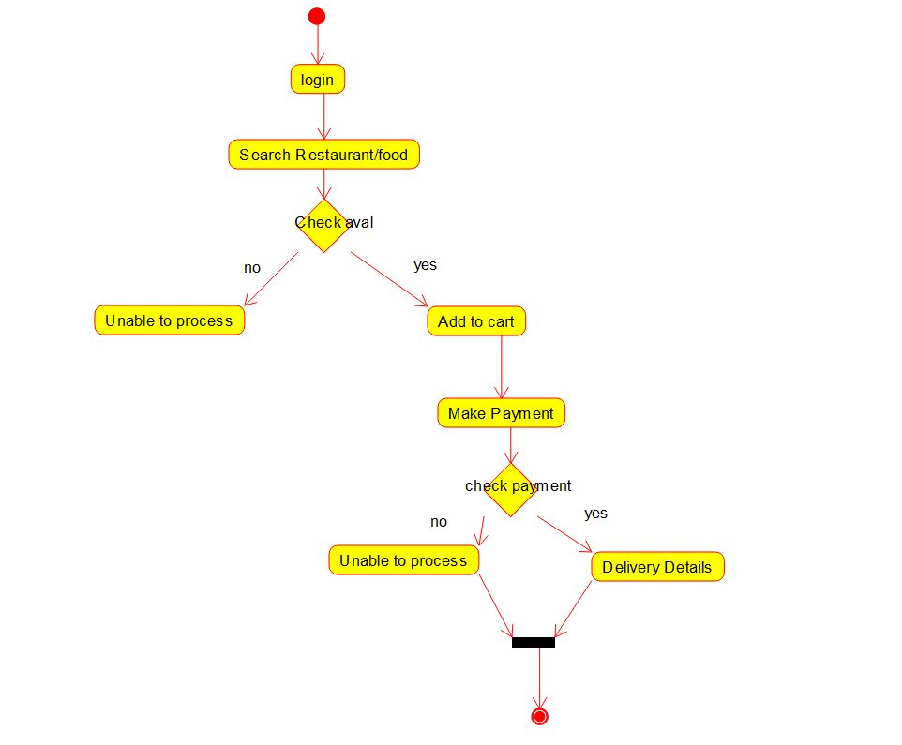

4.SEQUENCE DIAGRAM:

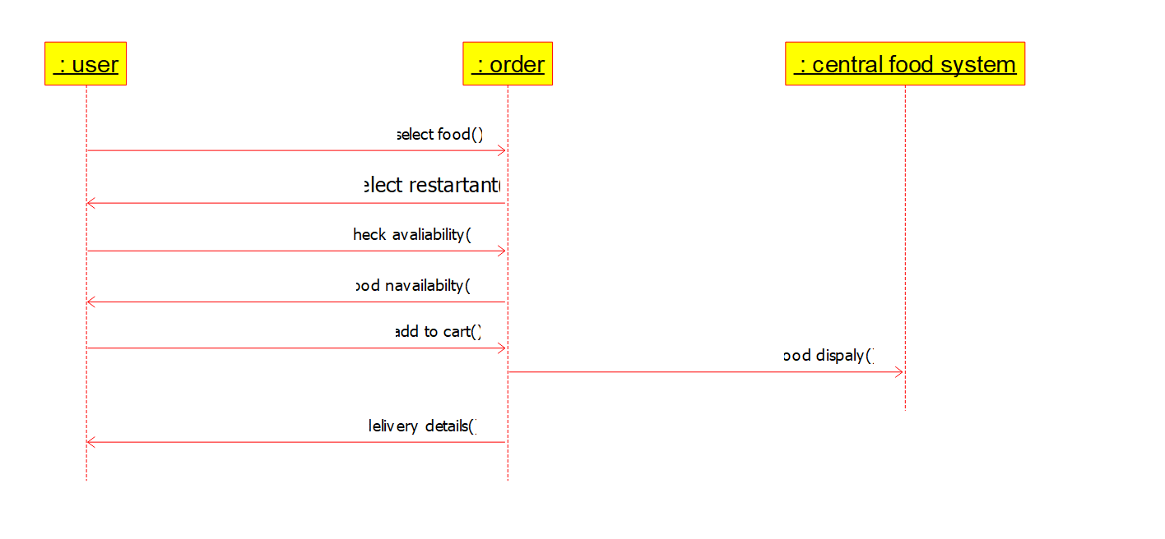

5.COLLABORATION DIAGRAM:

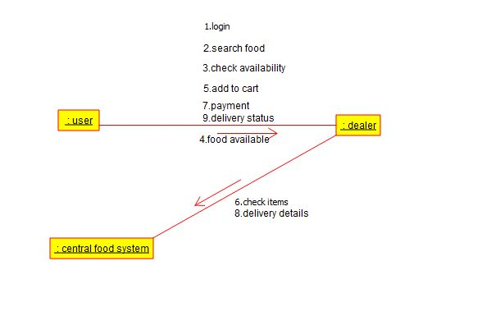

6.DEPLOYMENT DIAGRAM:

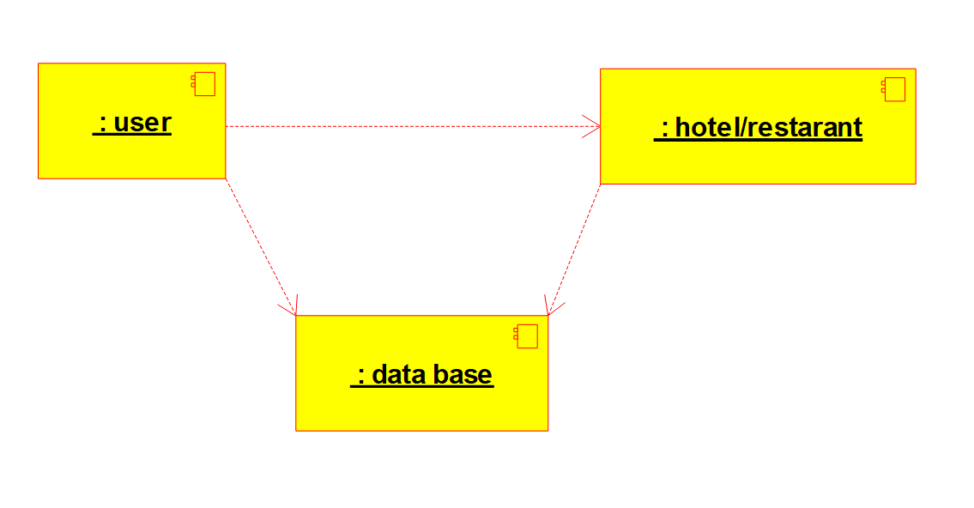

7.STATE DIAGRAM:

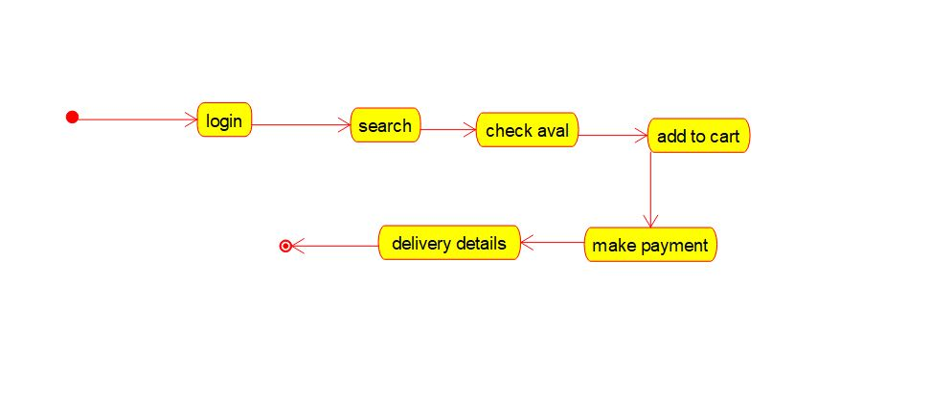

**11.** **Develop a system using UML for Library Management System. It should verify the details of the reader by the central computer. The details regarding the reader will be provided to the central computer through the administrator in the library and the computer will verify the details of the reader and provide approval to the office. Then the books that are needed by the reader will issue from the library to him.**

1.USE CASE DIAGRAM:

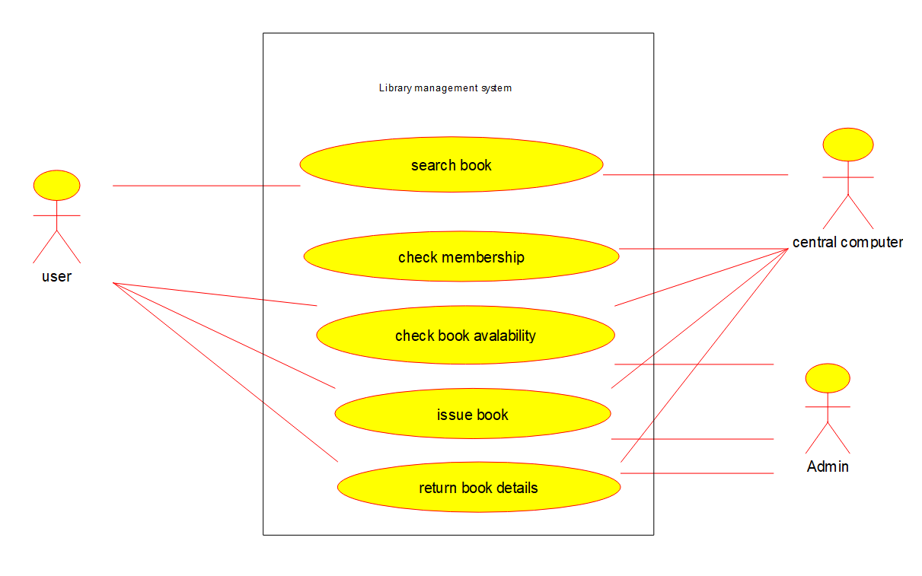

2.CLASSDIAGRAM:

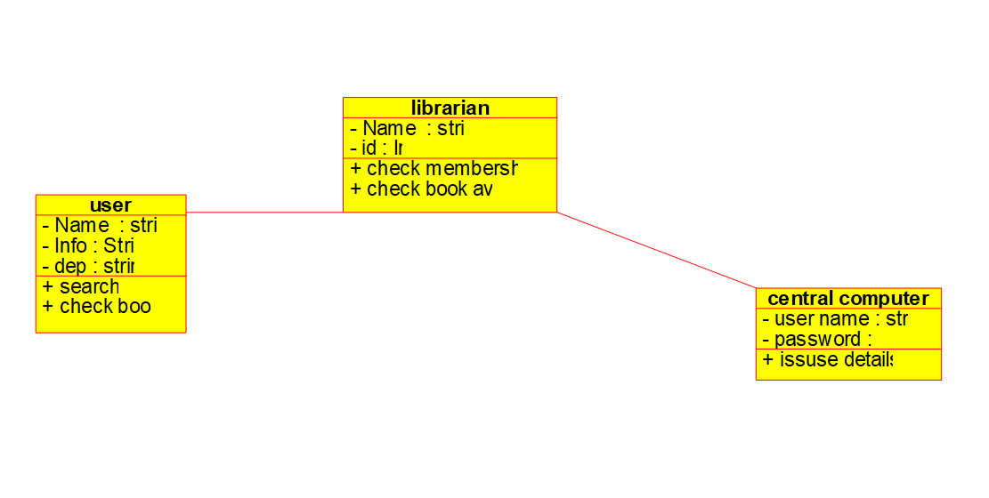

3.ACTIVITY DIAGRAM:

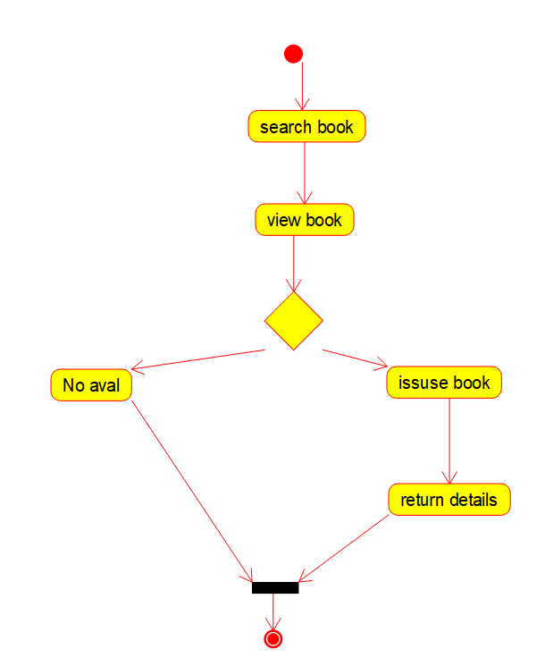

4.SEQUENCE DIAGRAM:

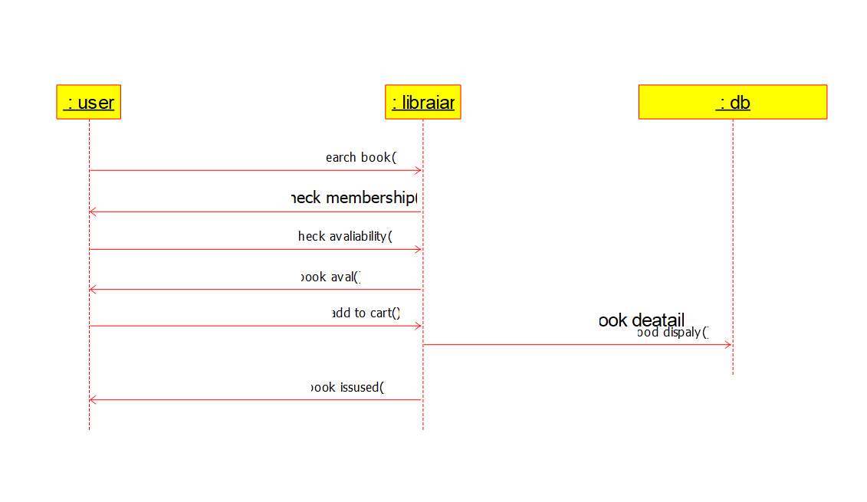

5.COMPONENT DIAGRAM:

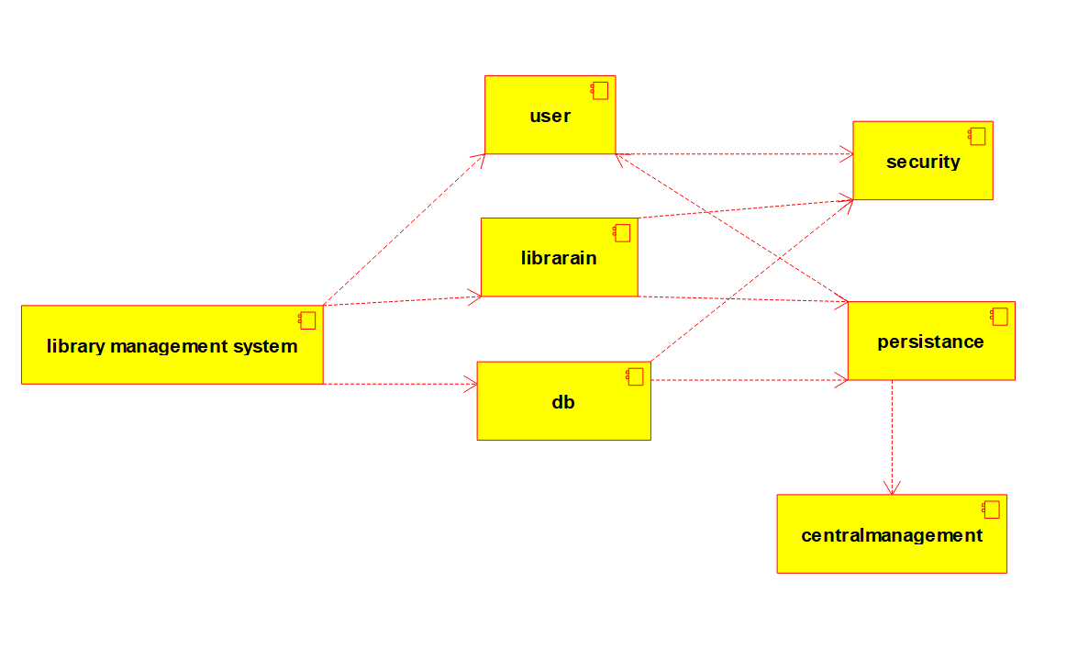

6.COLLABRATION DIAGRAM:

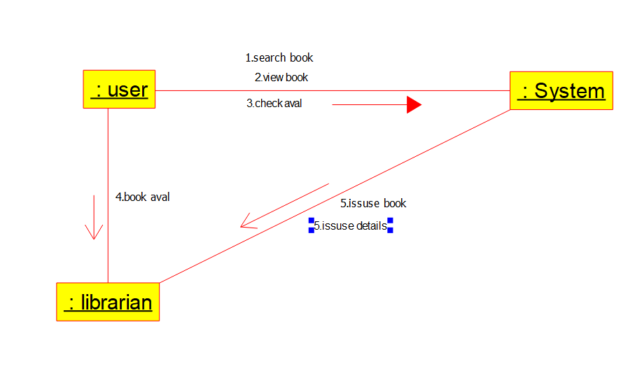

7.DEPLOYMENT DIAGRAM:

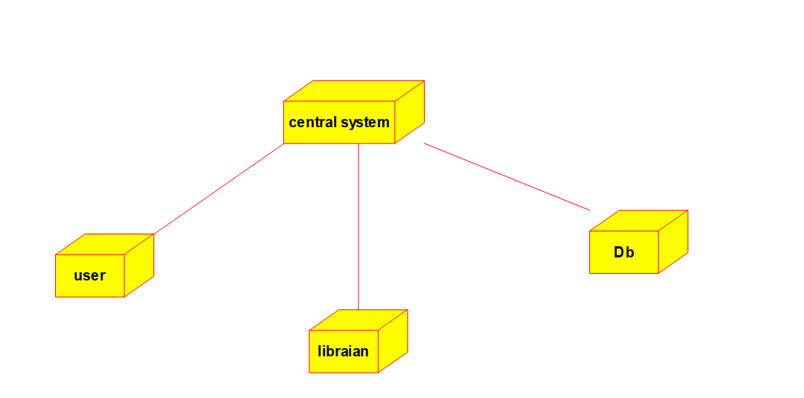

8.CLASSDIAGRAM:

